***USER MANUAL***

***CC CLIENT***

**Table of Contents**

1. **Login____________________________________________________________ pg 3**
2. **CC Client ________________________________________________________ Pg 5**

* **Work Order _______________________________________________ Pg 7**
* **Edit info _____________________________________________ Pg 9**
* **Work Order Edit ______________________________________ Pg 10**
* **Sample Collection ___________________________________________ Pg 11**
* **Sample Collection ______________________________________ Pg 11**
* **Sample Transfer _______________________________________ Pg 12**
* **Patient Dispatch Report _______________________________________ Pg 13**
* **Reports _____________________________________________________ Pg 14**
* **Client Deposit Report ___________________________________ Pg 14**
* **Change Password ___________________________________________Pg 15**
* **Invoice**
* **Ledger Report _________________________________________ Pg 16**
* **Advance Amount Payment_______________________________ Pg 18**
* **Invoice Reprint ________________________________________ Pg 20**

**LIS APPLICATION MANUAL**

**How to login in LIS**

For Client login in lis , the following steps needs to be done:

1. Open Website [**http://atulaya.com/**](http://atulaya.com/)

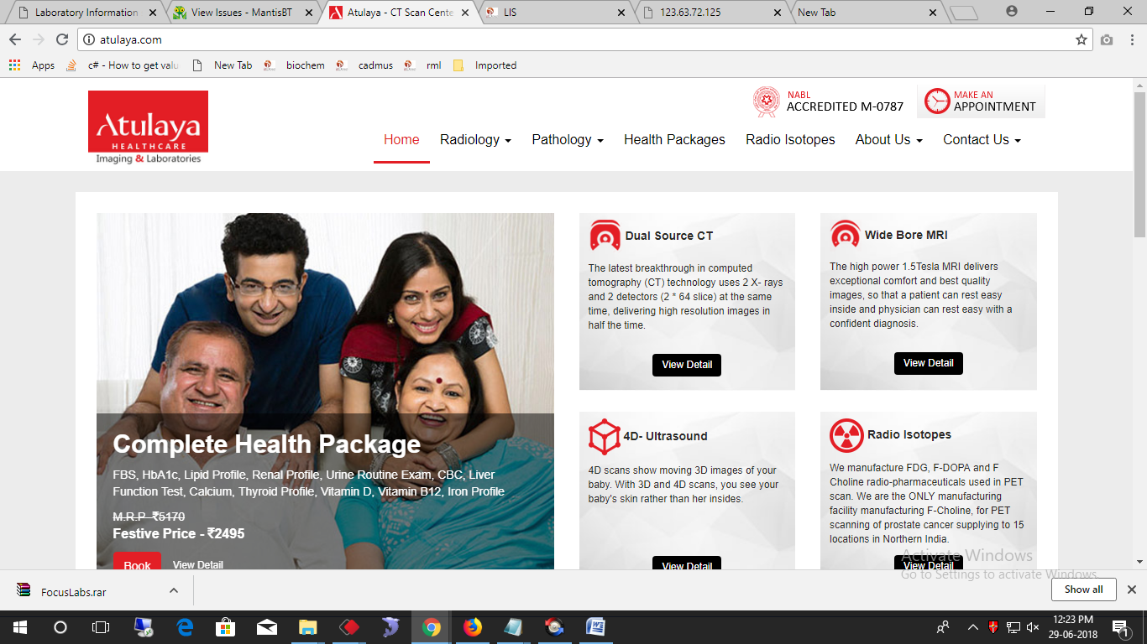

1. In the down most screen, there is button "Login to LIS". Click on the button to open the login LIS screen.
2. Select Login to LIS

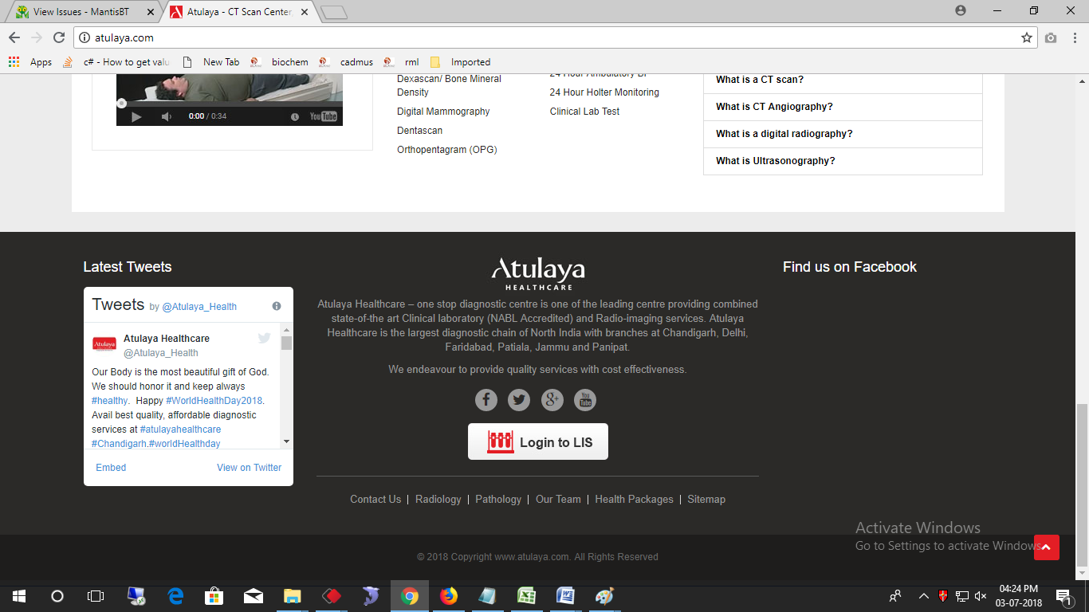

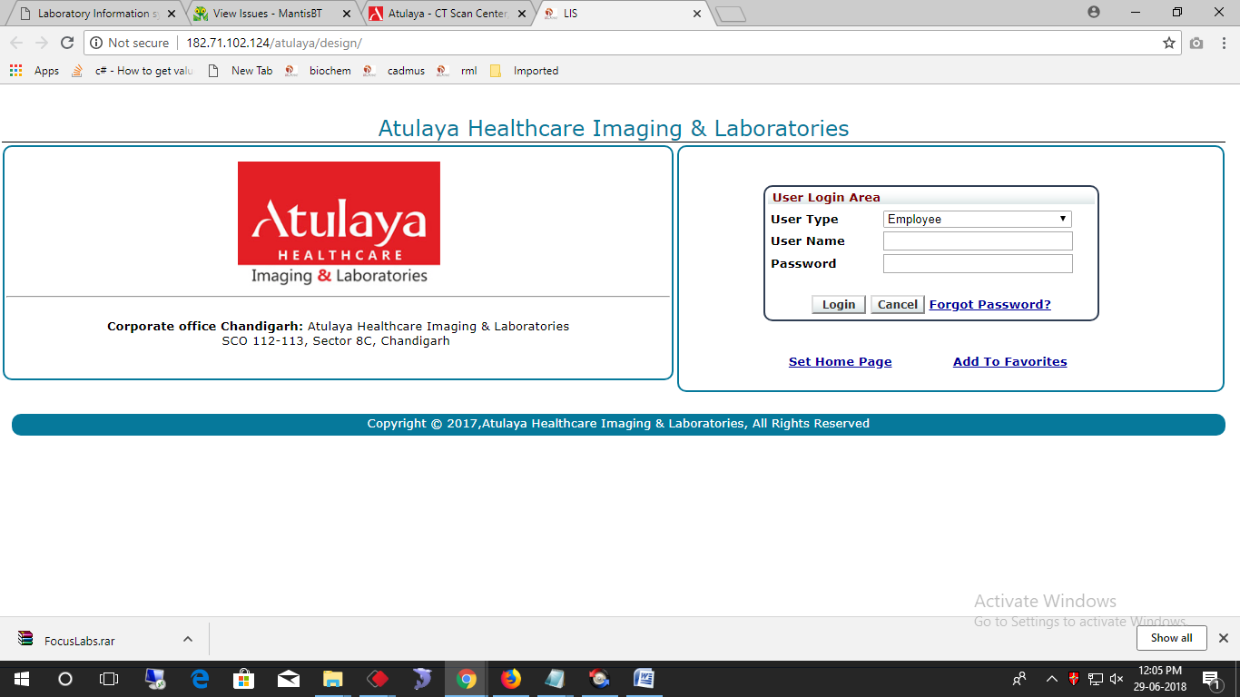

1. Enter the login credentials i.e, **Username** and **password** and click **login** .
2. This login page is for clients only .

**LIS APPLICATION MANUAL**

**This is the main login screen for the employee login.**

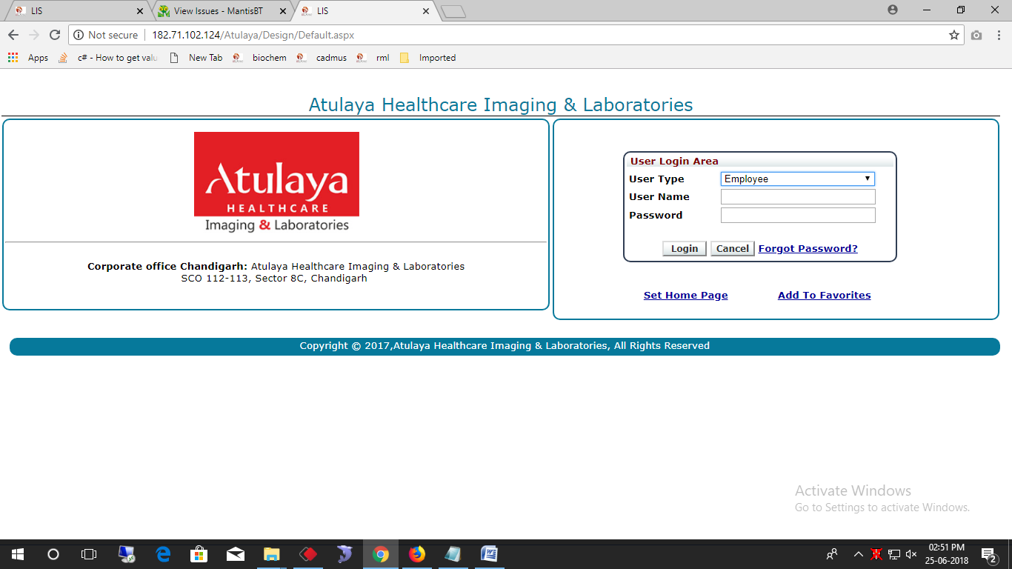

* **C2C Client**

From this screen , the patient can track the sample status by entering **SIN No./Visit Entry No./Barcode no.** in the **sample tracker** option**. If the Received Amount is less than credit limit then It will blink in red color, if the received amount is greater than the credit limit , it will blink in green color.**

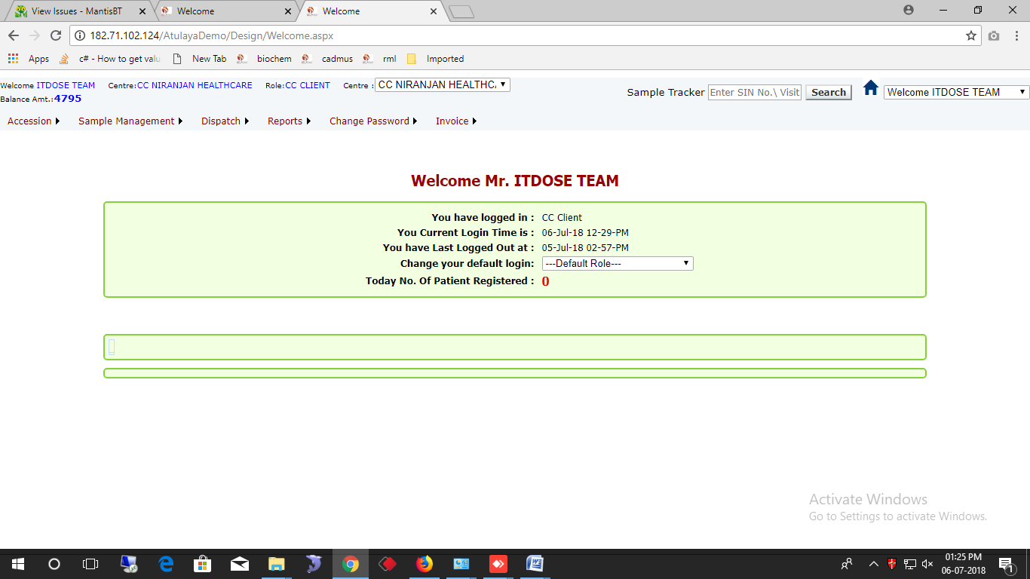

**Username**

**Role Name**

**Centre name**

1. **Work Order**

The work order page is used for registration of new patient. The fields marked in red are mandatory fields , it can’t be left blank when doing registration. We can create new doctor by clicking New option and then the popup will appear for creating new doctor. The new doctor created from here will first be verified by admin , then if admin approves the same the doctor is added to the masters.

The bank details name, cheque no. and cheque date has to be mentioned when the payment is done by cheque.

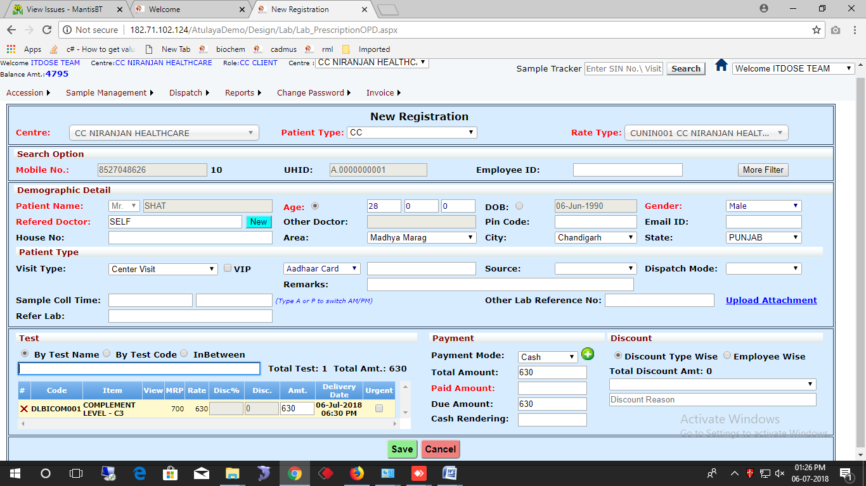

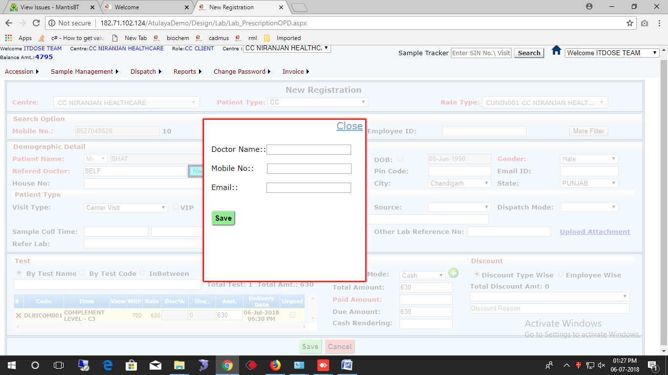

**Patient Receipt**

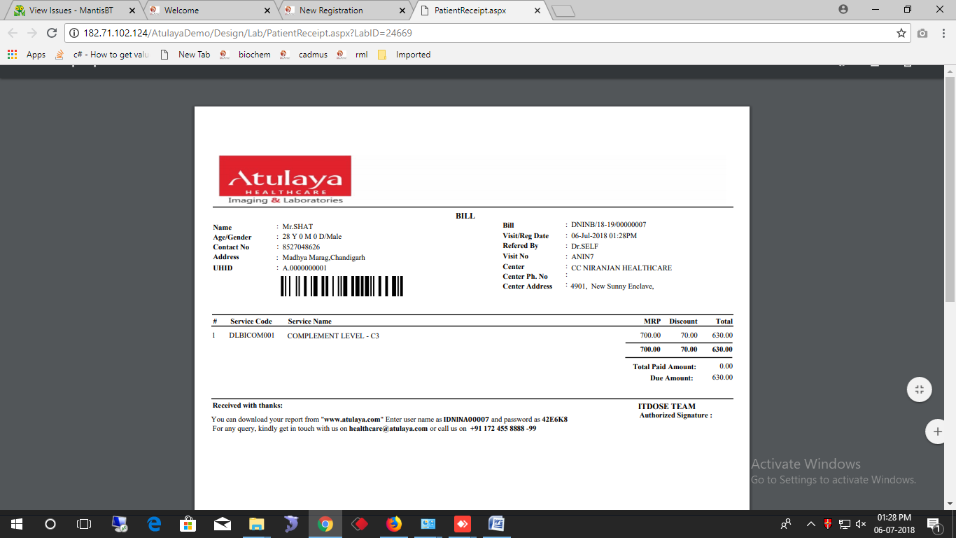

* 1. **Edit Info**This screen is used to edit personal information of the patient. Enter the labno. In the field then click search. The records will be fetched automatically and the details of the patient can be edited.

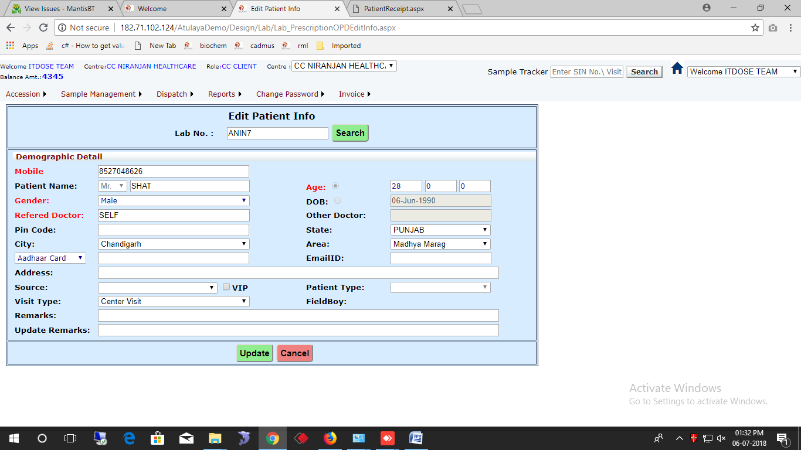

**Enter labno. And then click search.**

* 1. **Work Order Edit**

This screen is used to edit the work order created , i.e, if any new test has to be added or the refer doctor can be edited . The work order can be edited before sample transfer only. After Sample Transfer the work order can’t be edited. Enter the labo. And click **Search.**

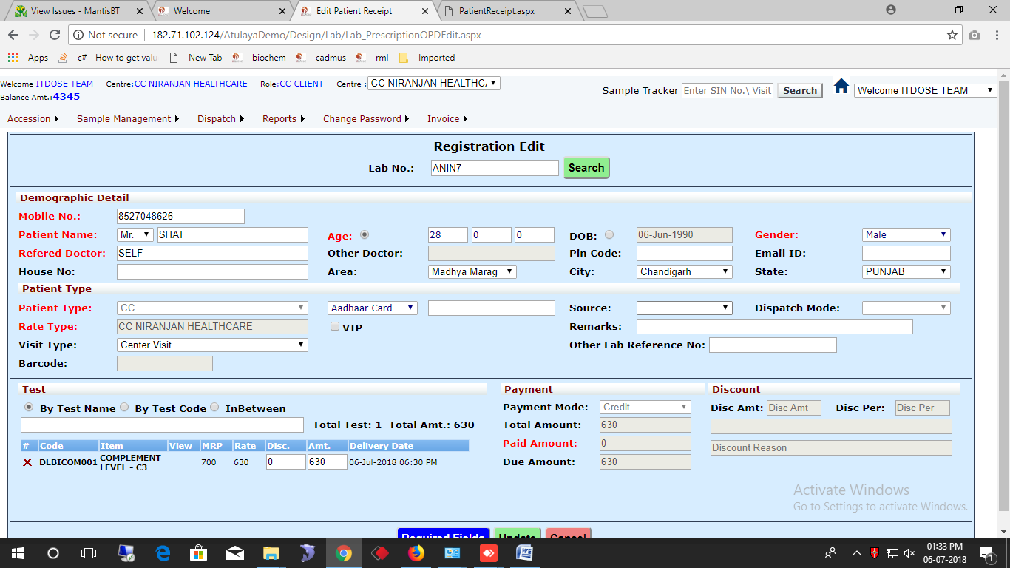

**Enter Labno. And search**

1. **Sample Collection**This screen is used for collecting sample of the patient. The total patients whose sample has to be collected will appear in this screen. Then, the sample is collected. The sample is collected when we select **Collect** option.

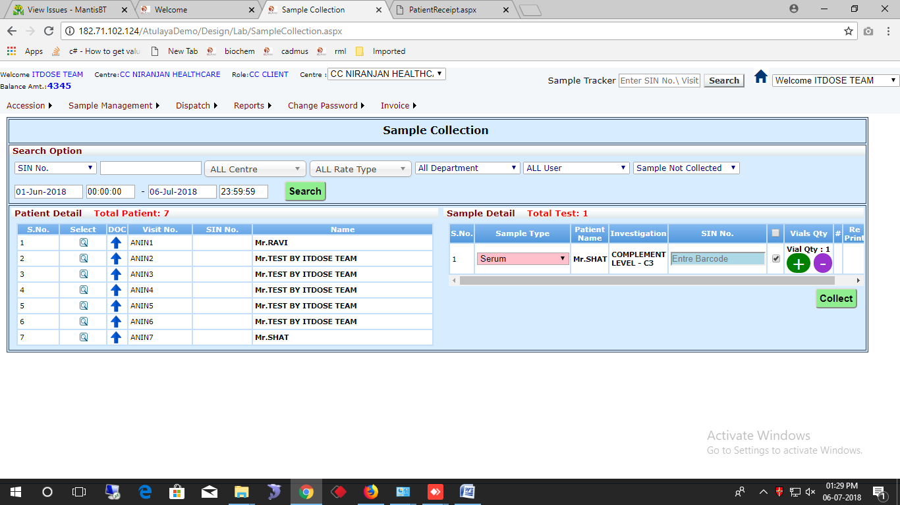

**2.1) Sample Transfer**

This screen is used to transfer sample to other centre. The SIN No. or Barcode no. is entered then a batch is created . After batch creation , it is transferred to the center.

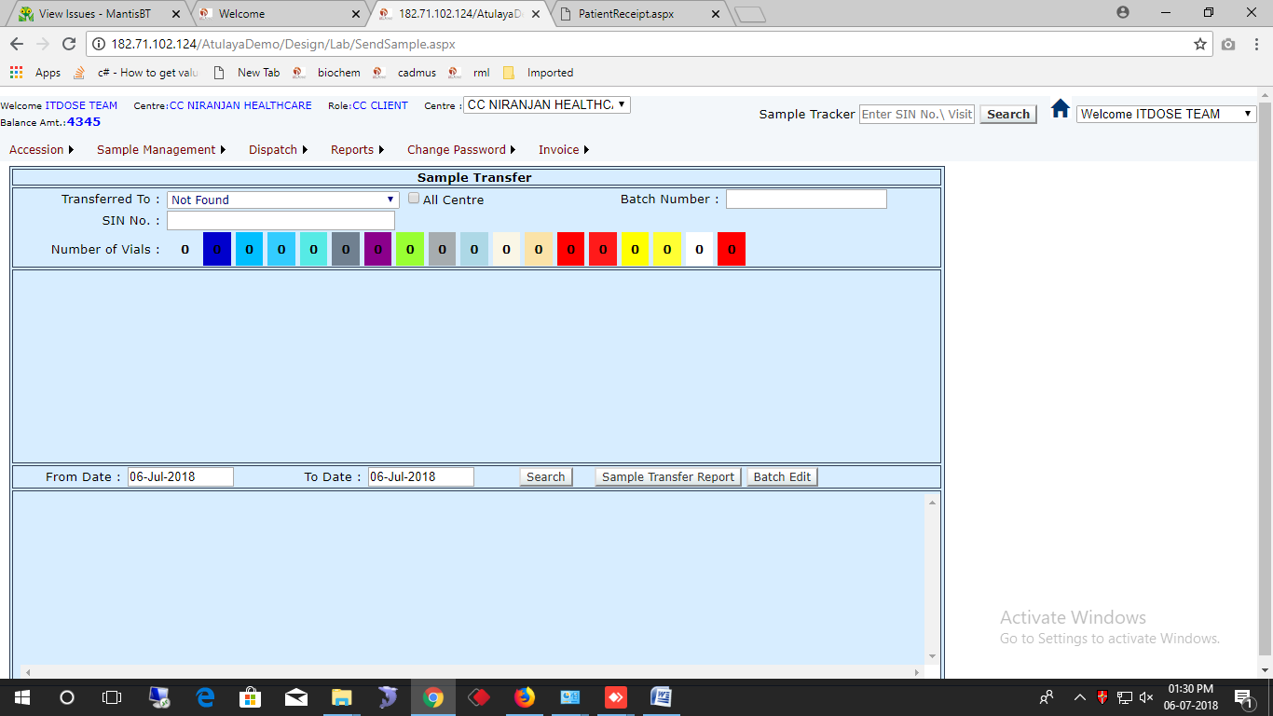

1. **Patient Dispatch Report**

This screen is used for printing patient report and result entry of the patient. The total patient information will load here and we can collect samples if the patients.

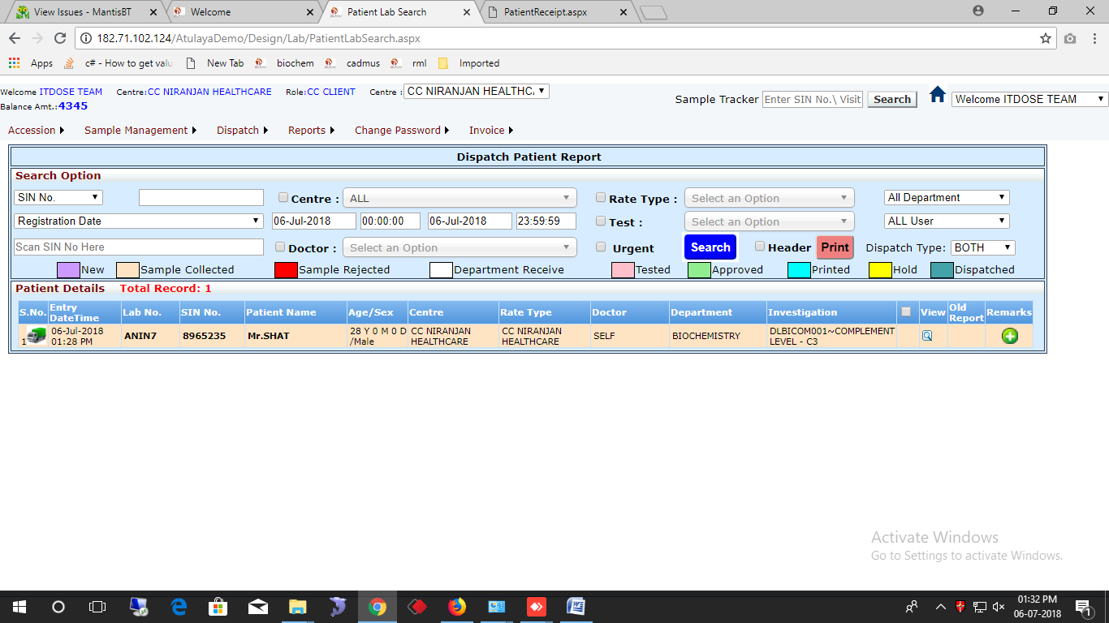

1. **Reports**

**4.1) Client Deposit Report**

This report is the summary of the total cash deposited by the client using different mode of payment.

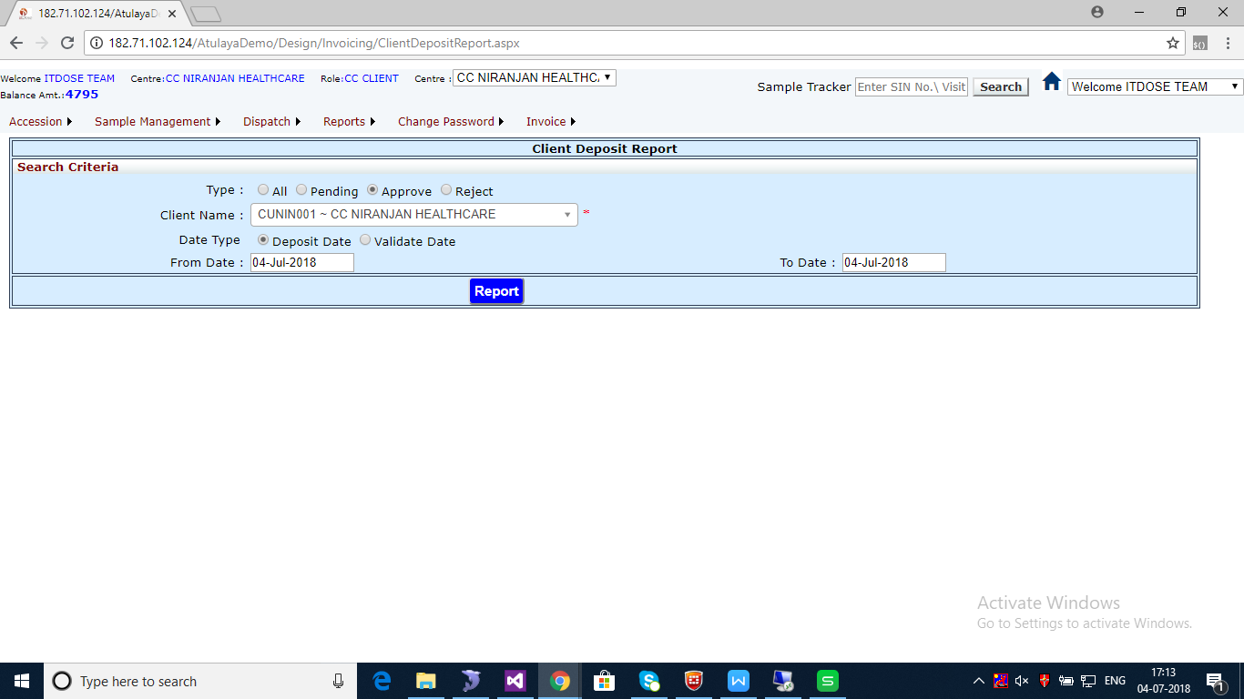

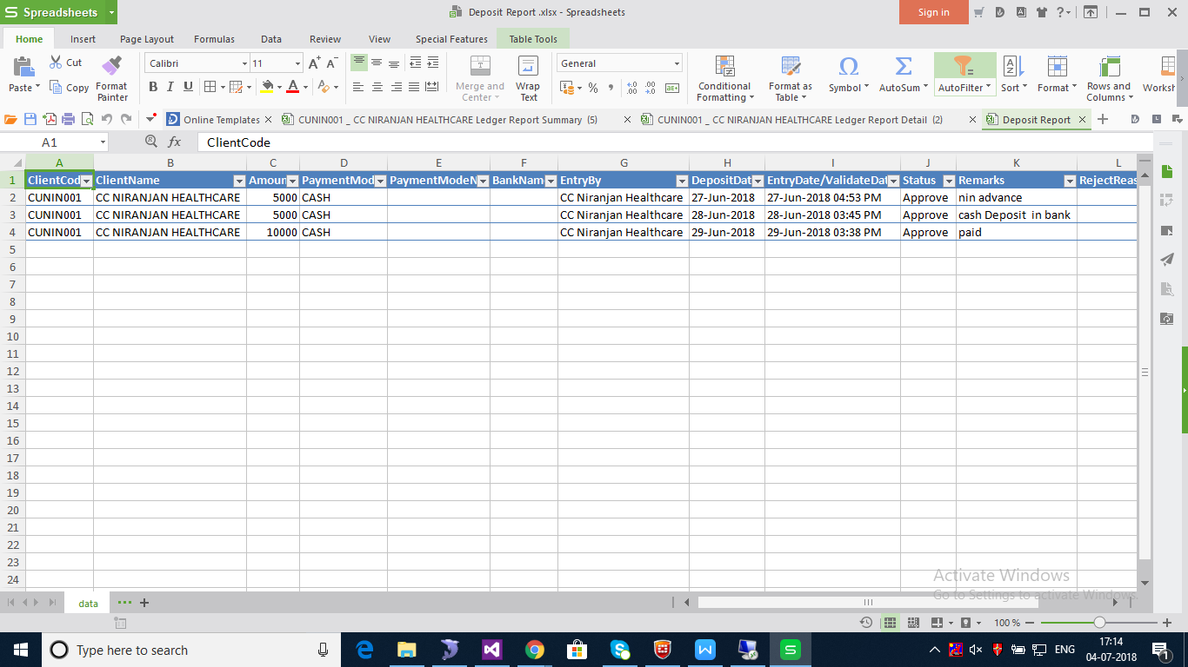

1. **Change Password**

This screen is used to change login password of the user.

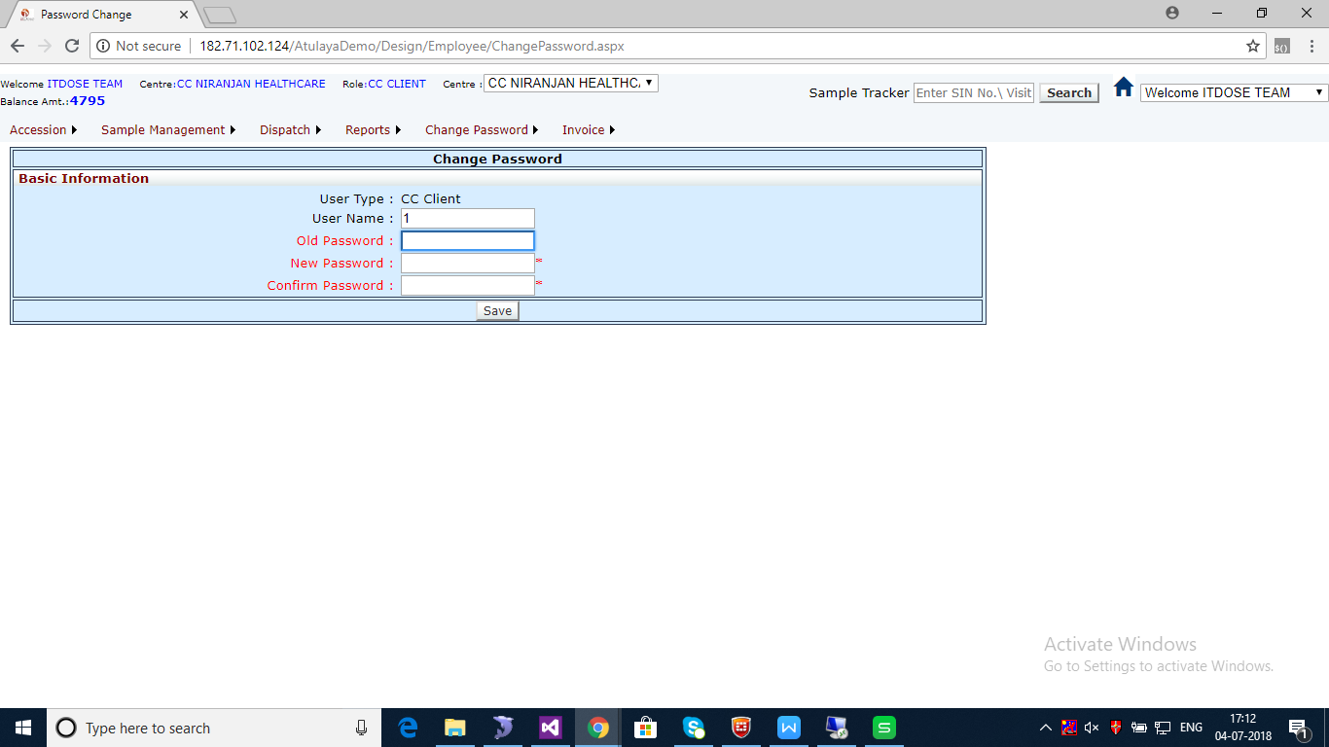

1. **INVOICE**

**6.1) Ledger Report**

Ledger Report is the report summary of the client, i.e, the amount submitted , invoice no. , Client name, Client code etc.

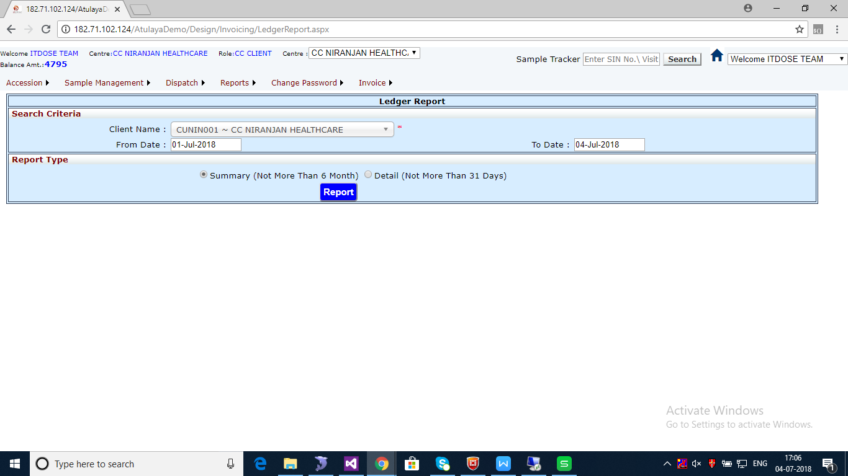

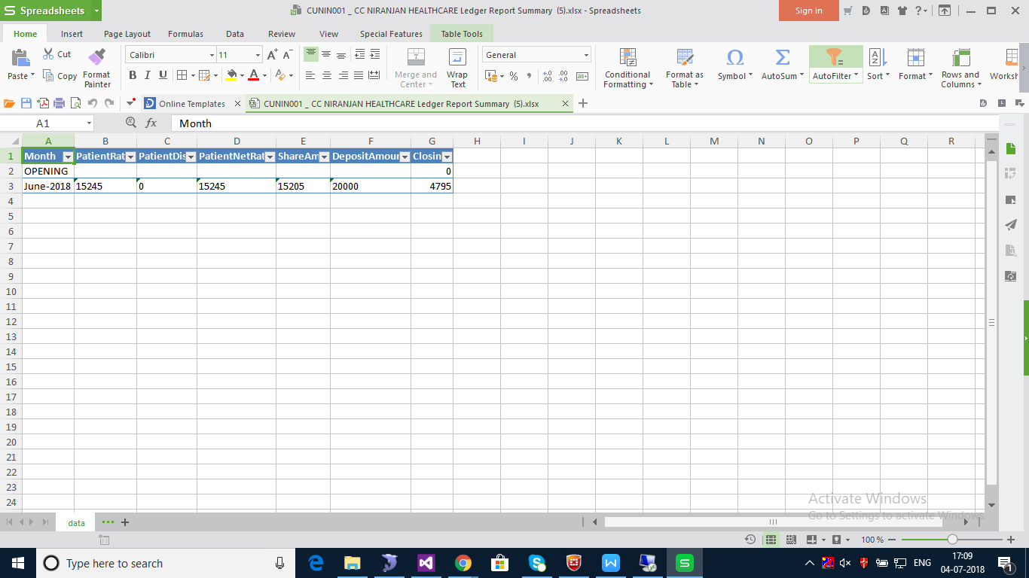

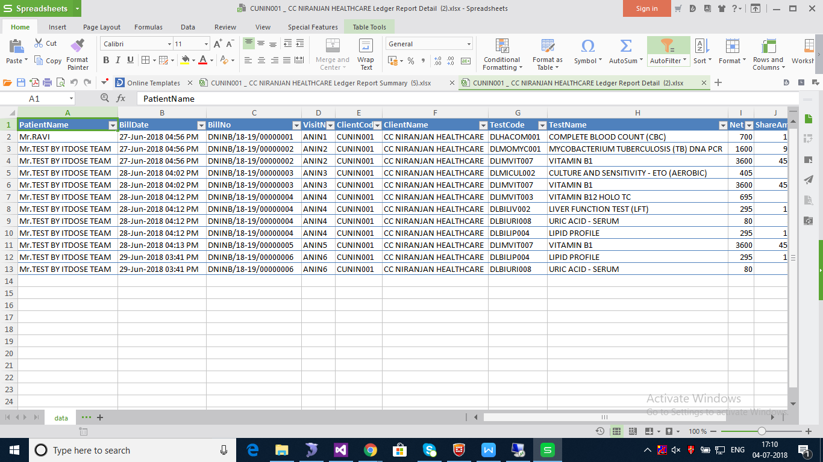

**6.2) Advance Amount Payment**

This screen is used for making advanced payment for the client. For this, the client name is selected , then the payment mode i.e, cash, cheque, Demand Draft, NEFT, RTGS, IMPS . Then the amount is entered then the record is saved. The record saved is first verified then it is submitted in the software.

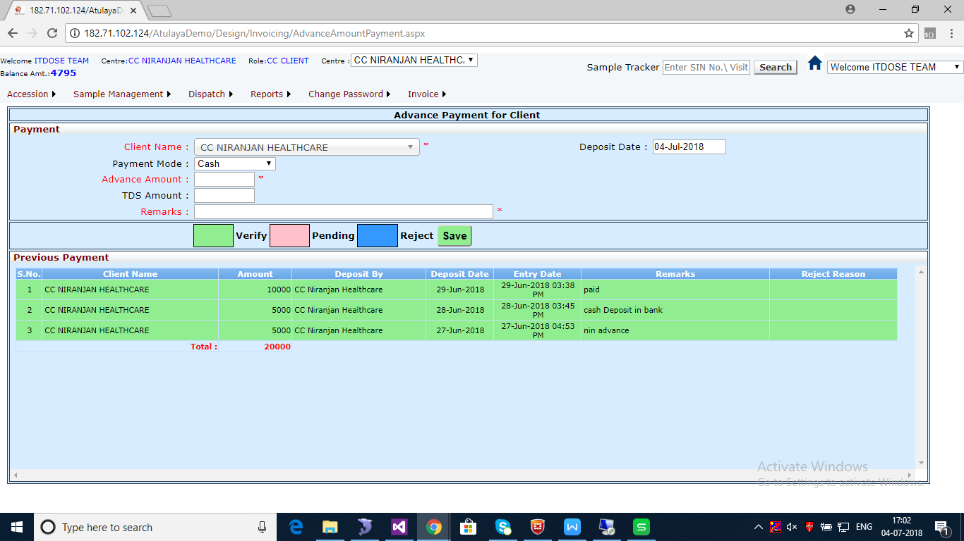

**The different payment mode is shown the screenshot mentioned below:**

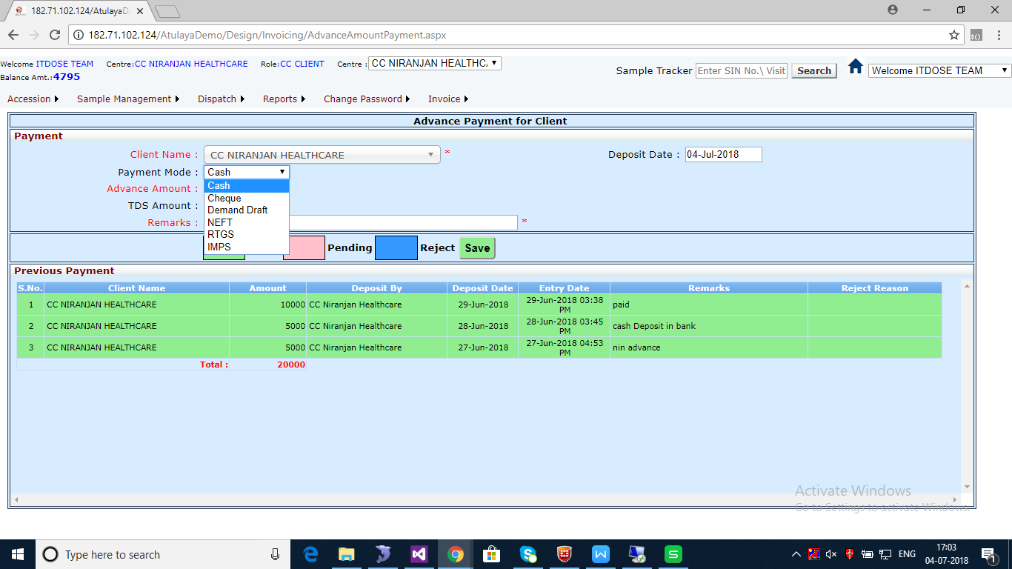

**When Cheque is selected as payment mode, following screen appears.**

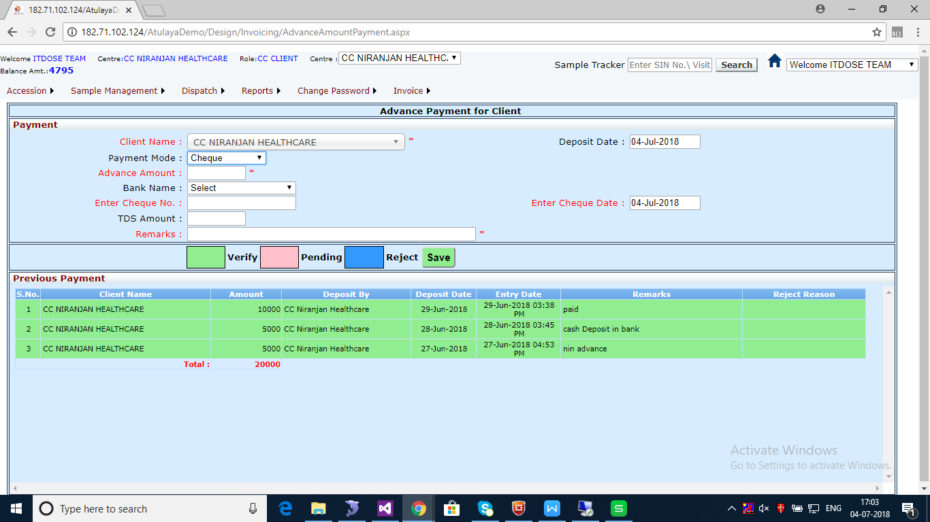

**6.3) Invoice Reprint**

In this screen , the invoice generated is searched by adding from date and to date , client is selected and the invoice will be searched and can be reprinted .

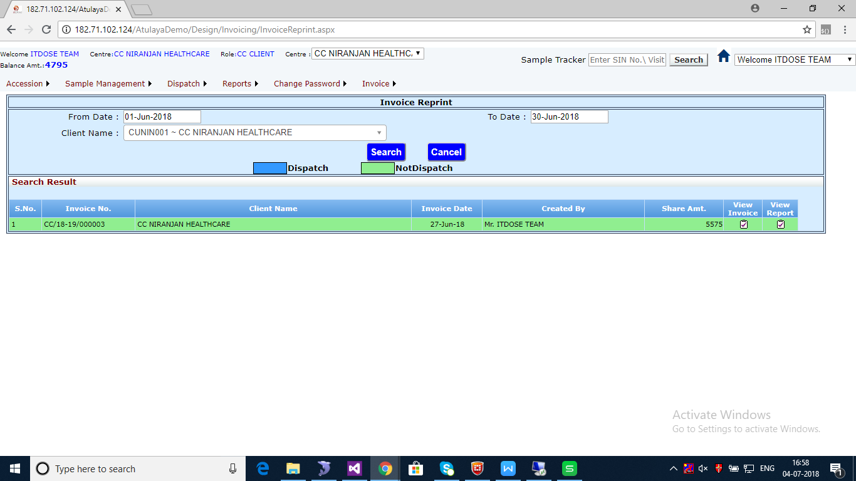

When **View Invoice** option is clicked, the following report appears.

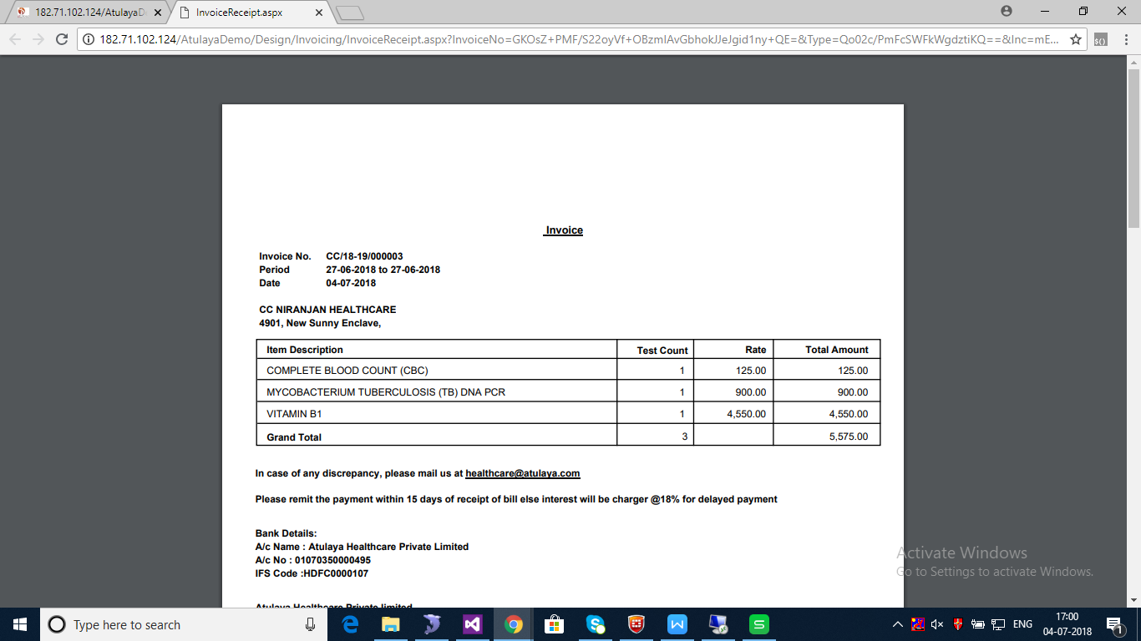

When **ViewReport** option is clicked, the following report appears:

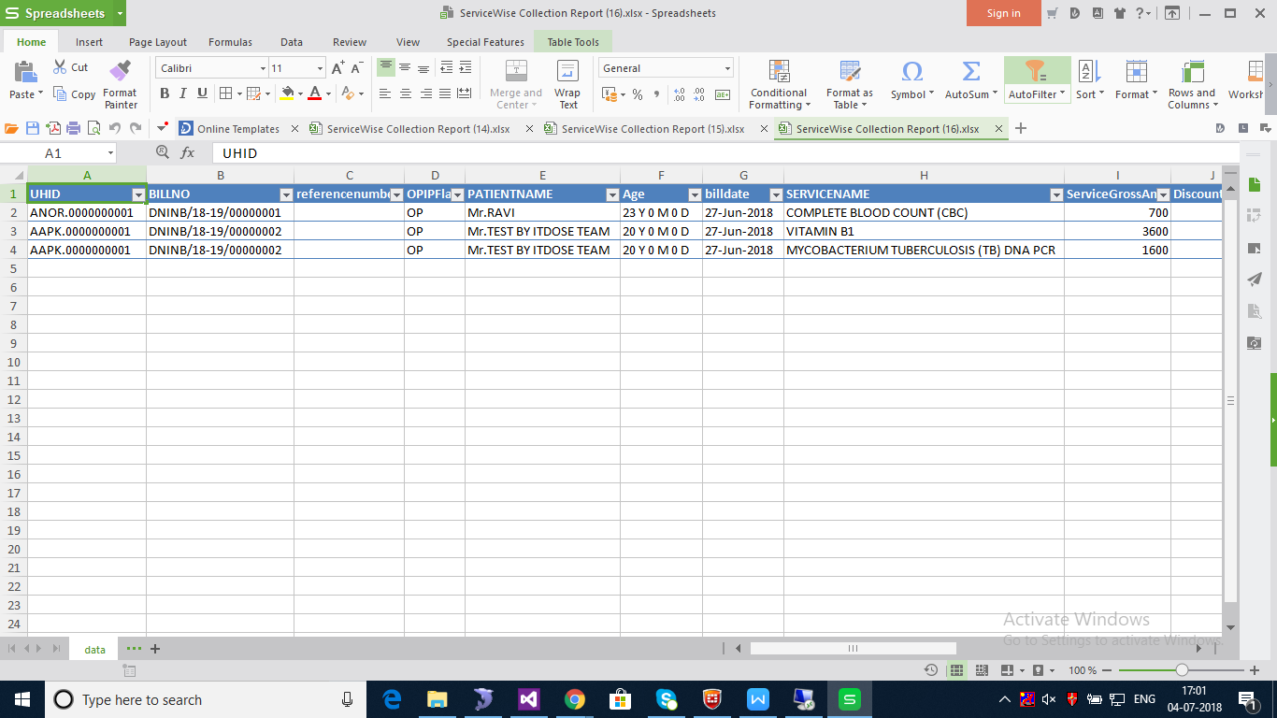

**_______________________________________ The End____________________________________**